Perpendicular Bisector

Definition
# Source: AI Source: Provided by: [Data Path: Persons Table -> ID Column: 1, Name_En Column: Motasem Essam] -> From: [ChatGPT] on [7/25/2026]
A perpendicular bisector is a line that divides a line segment into two congruent segments and intersects the segment at a right angle.
If line $l$is the perpendicular bisector of $\overset{‾}{AB}$, intersecting it at $M$, then:
$$\boxed{AM=MB}$$
and:
$$\boxed{l⊥\overset{‾}{AB}}$$
Therefore:
$$\boxed{∠AMl=∠BMl={90}^{∘}}$$
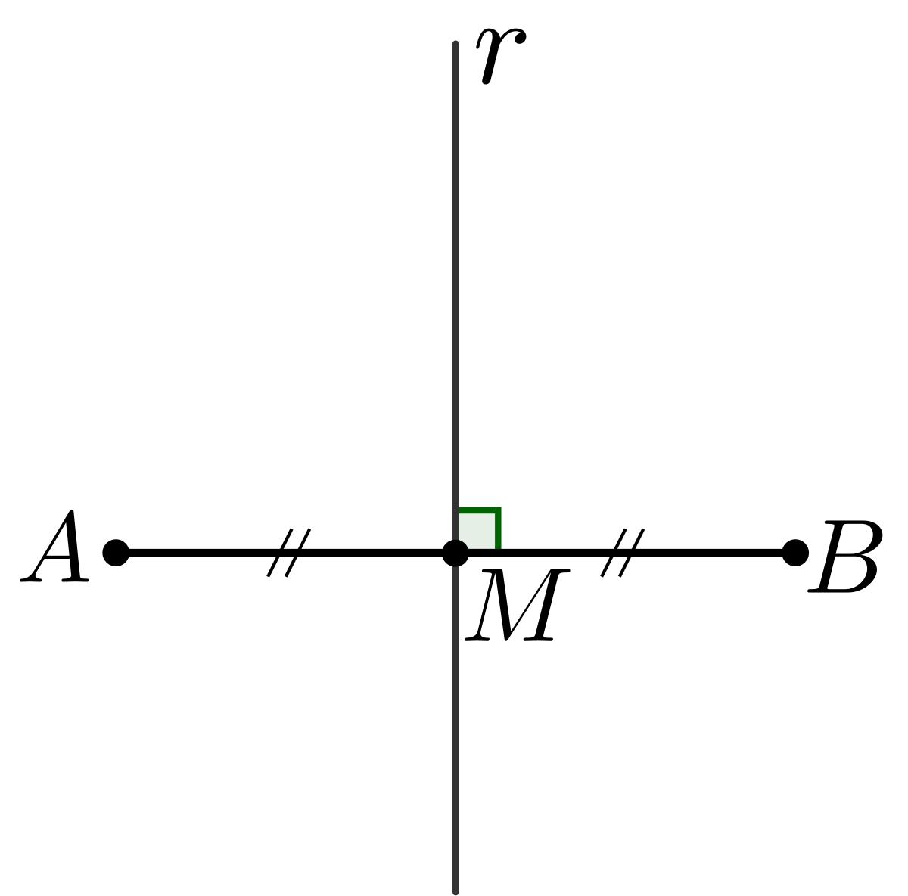
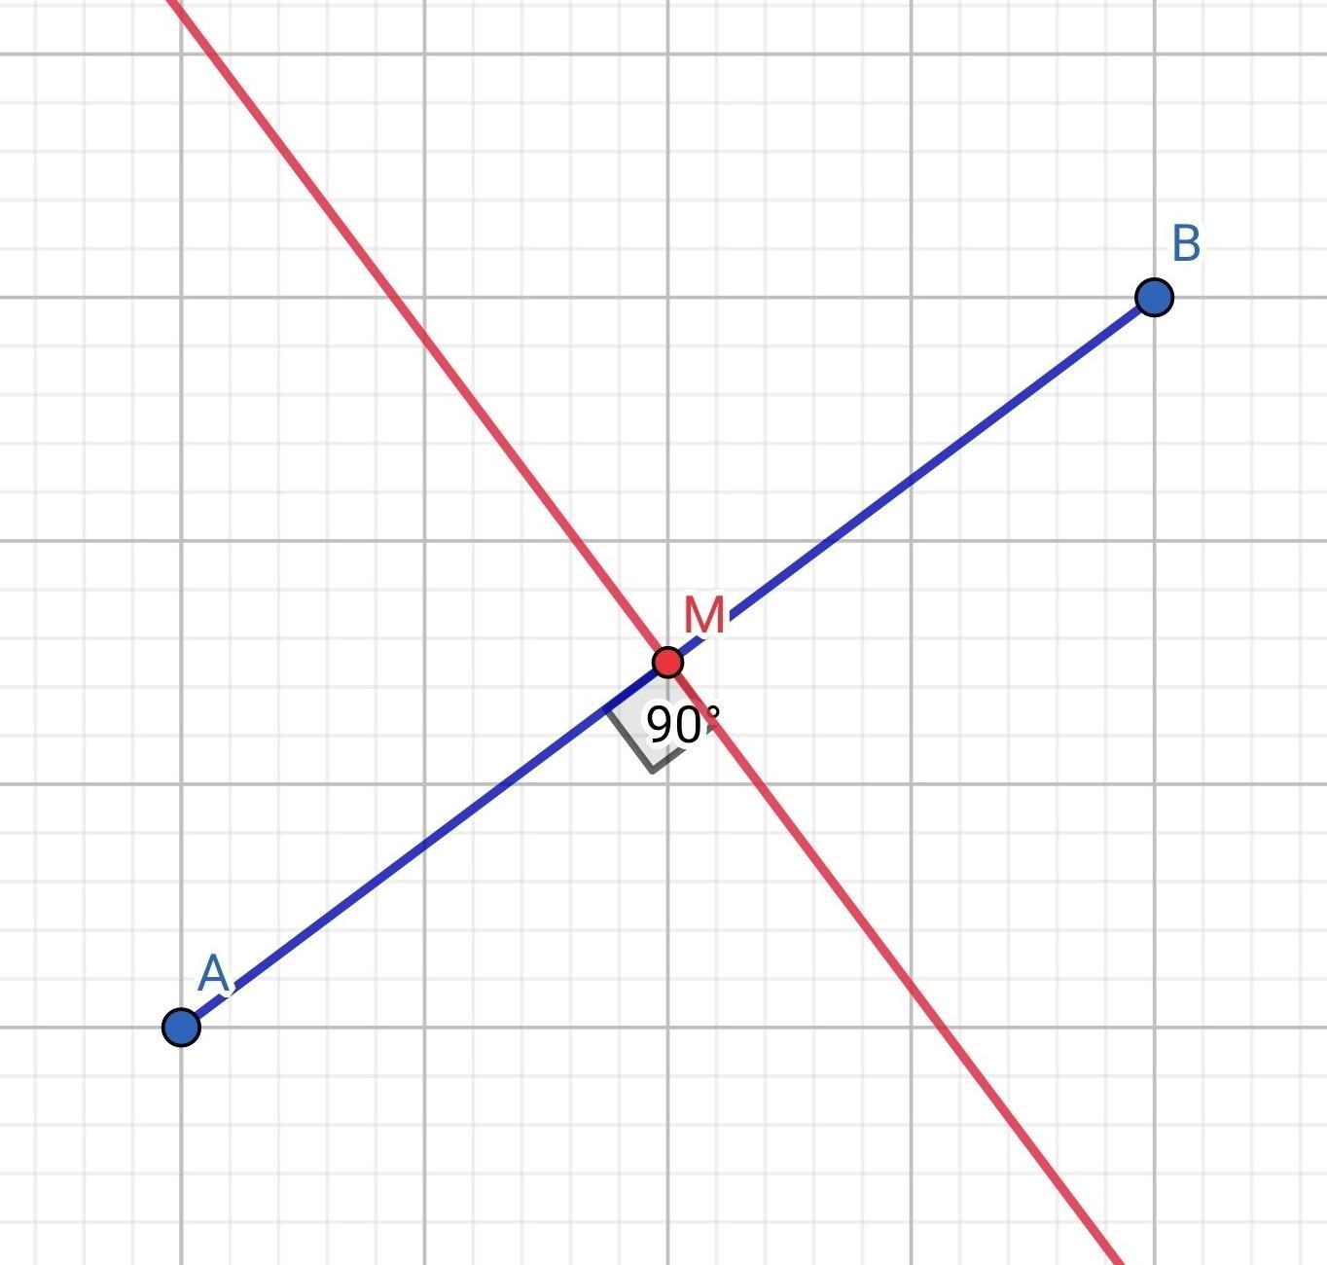
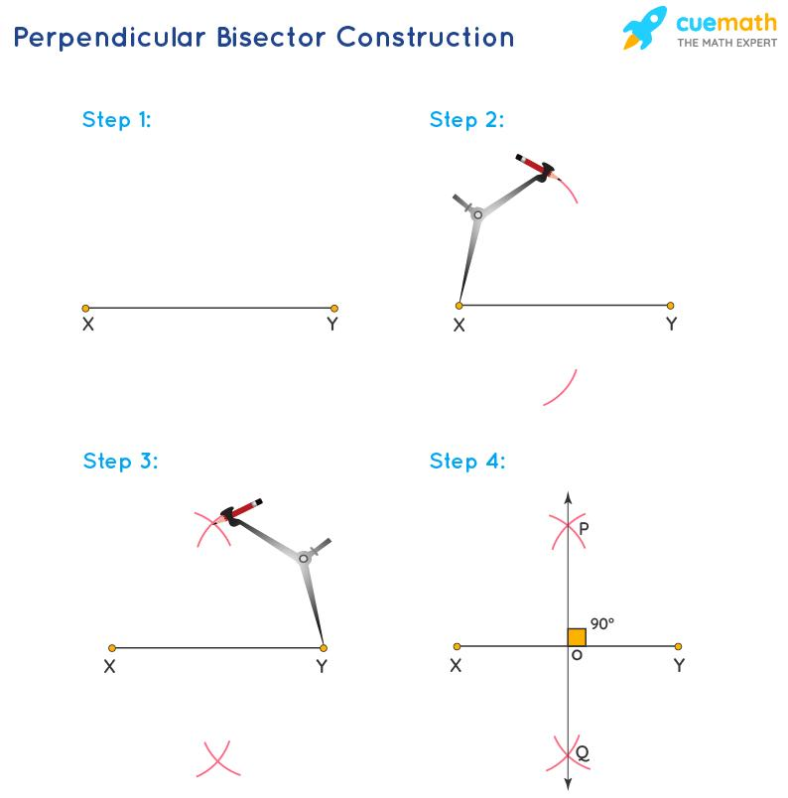
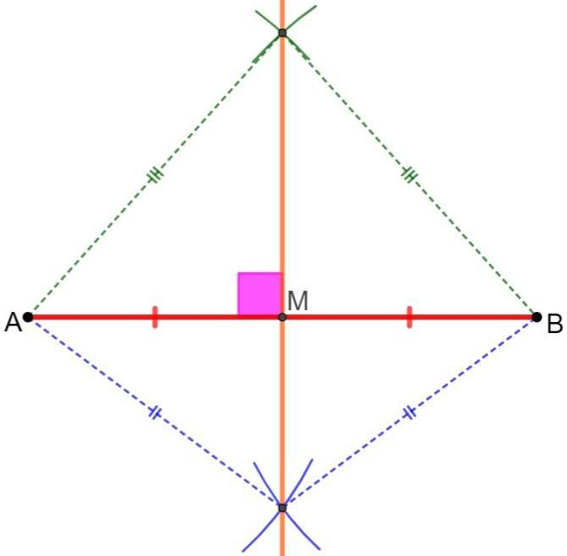
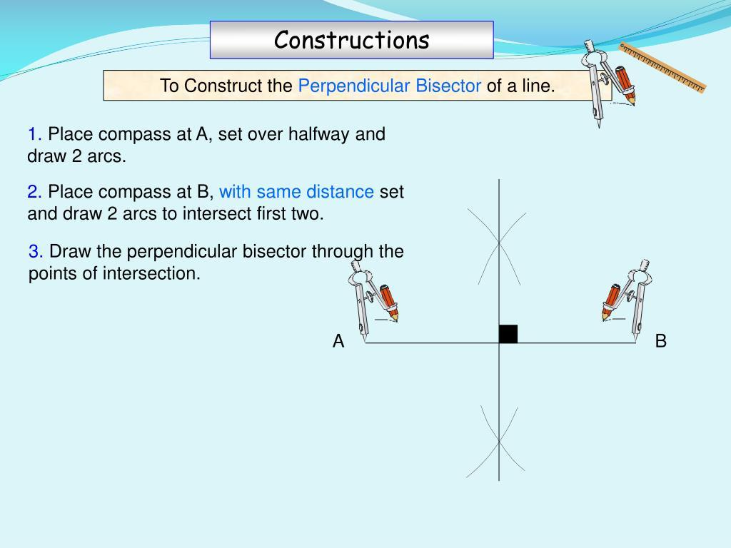

Purpose
# Source: AI Source: Provided by: [Data Path: Persons Table -> ID Column: 1, Name_En Column: Motasem Essam] -> From: [ChatGPT] on [7/25/2026]
A perpendicular bisector is used to:
- Find the midpoint of a line segment.
- Divide a segment into two equal parts.
- Construct perpendicular lines.
- Find the circumcenter of a triangle.
- Determine points that are equidistant from two given points.
- Construct geometric figures with symmetry.

Basic Configuration
# Source: AI Source: Provided by: [Data Path: Persons Table -> ID Column: 1, Name_En Column: Motasem Essam] -> From: [ChatGPT] on [7/25/2026]
Consider segment:
$$\overset{‾}{AB}$$
Let line $l$intersect $\overset{‾}{AB}$at $M$.
For $l$to be the perpendicular bisector:
1. It must bisect the segment
$$\boxed{AM=MB}$$
2. It must be perpendicular to the segment
$$\boxed{l⊥\overset{‾}{AB}}$$
Thus $M$is the midpoint of $\overset{‾}{AB}$.
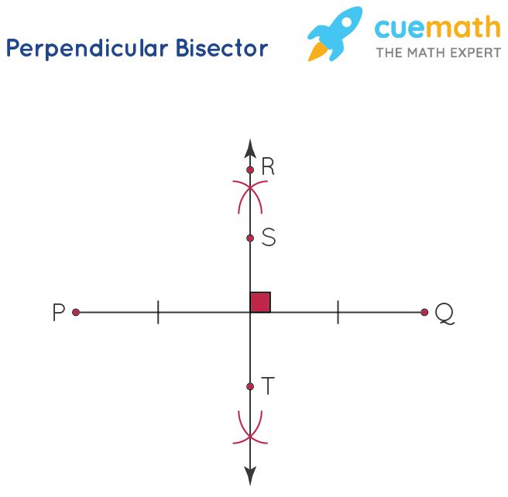
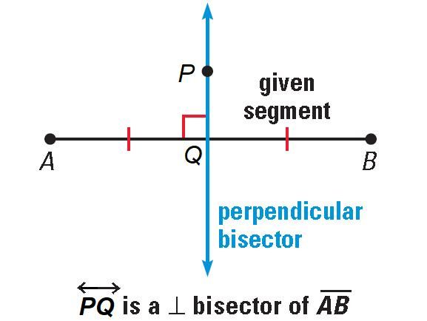
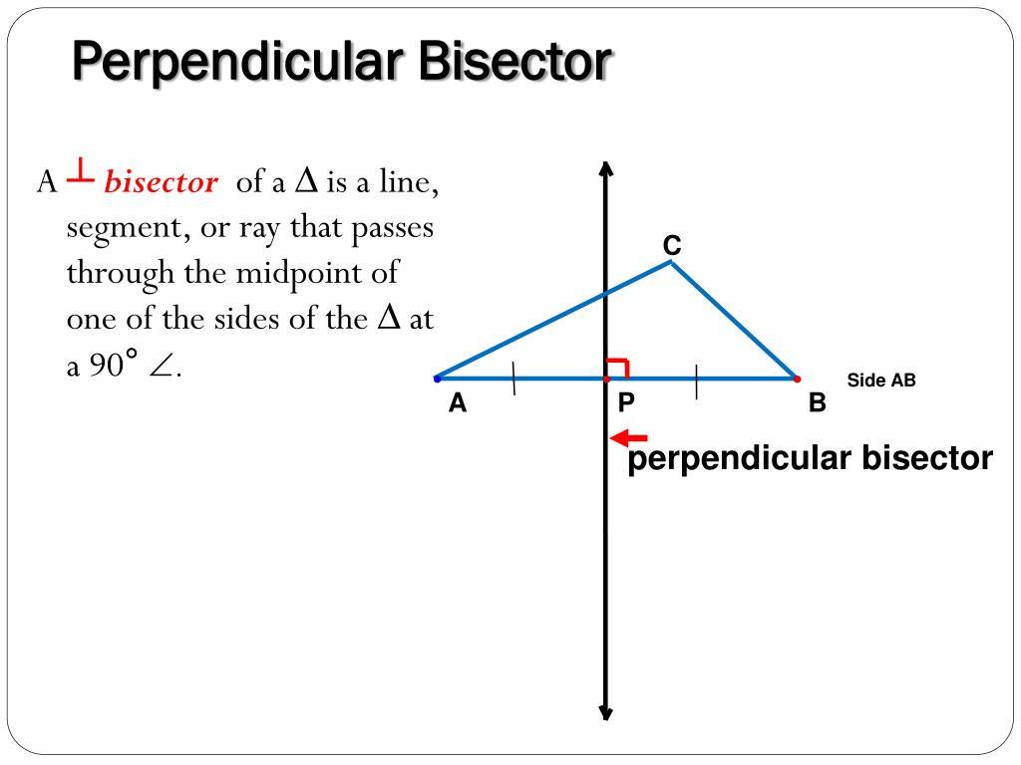

Fundamental Properties
# Source: AI Source: Provided by: [Data Path: Persons Table -> ID Column: 1, Name_En Column: Motasem Essam] -> From: [ChatGPT] on [7/25/2026]
If $l$is the perpendicular bisector of $\overset{‾}{AB}$, then:
$$\boxed{AM=MB}$$
and:
$$\boxed{l⊥\overset{‾}{AB}}$$
These two conditions define a perpendicular bisector.

Perpendicular Bisector Theorem
# Source: AI Source: Provided by: [Data Path: Persons Table -> ID Column: 1, Name_En Column: Motasem Essam] -> From: [ChatGPT] on [7/25/2026]
The Perpendicular Bisector Theorem states:
Any point on the perpendicular bisector of a line segment is equidistant from the segment's two endpoints.
If $P$lies on the perpendicular bisector of $\overset{‾}{AB}$, then:
$$\boxed{PA=PB}$$
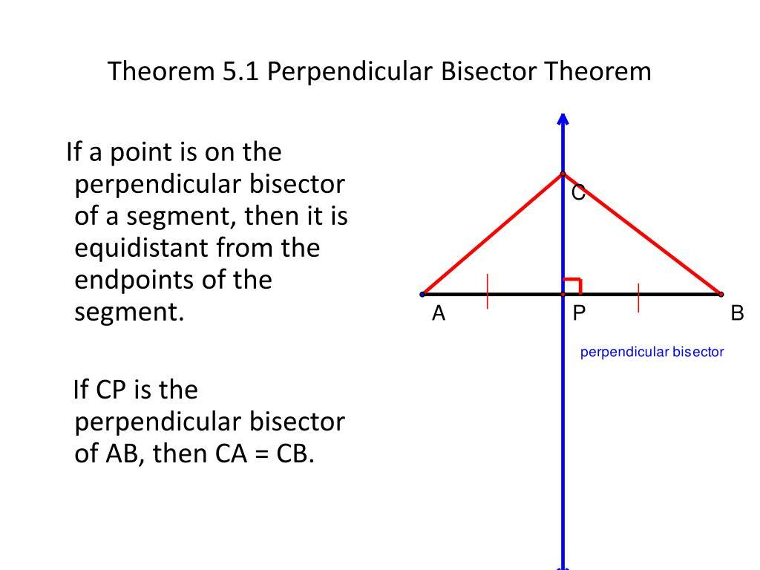
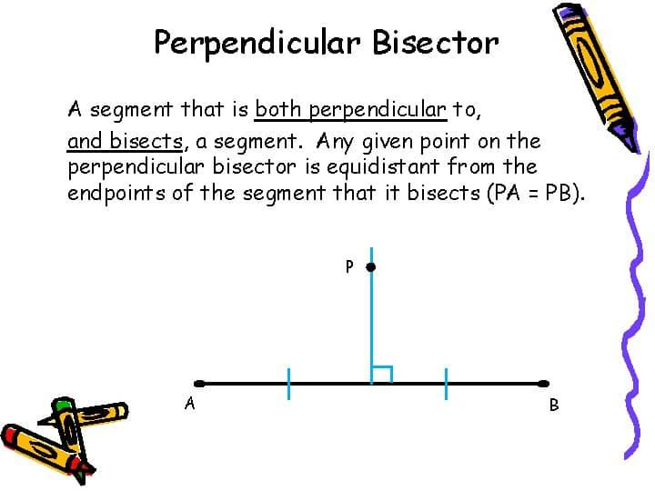
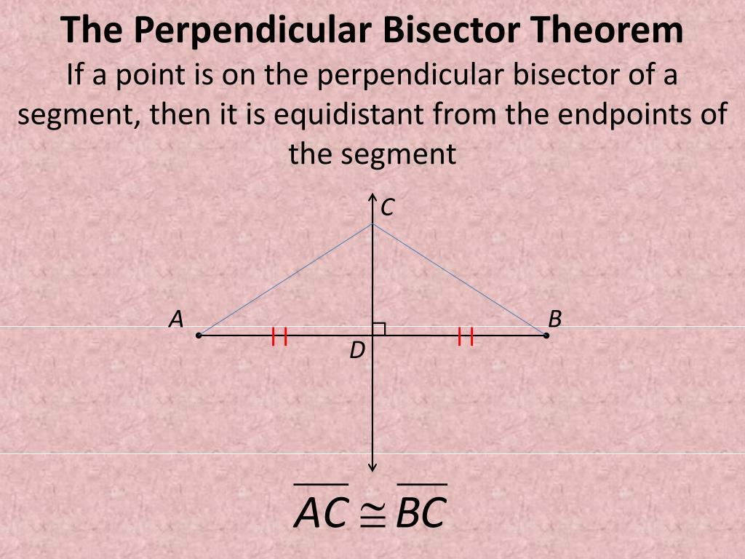
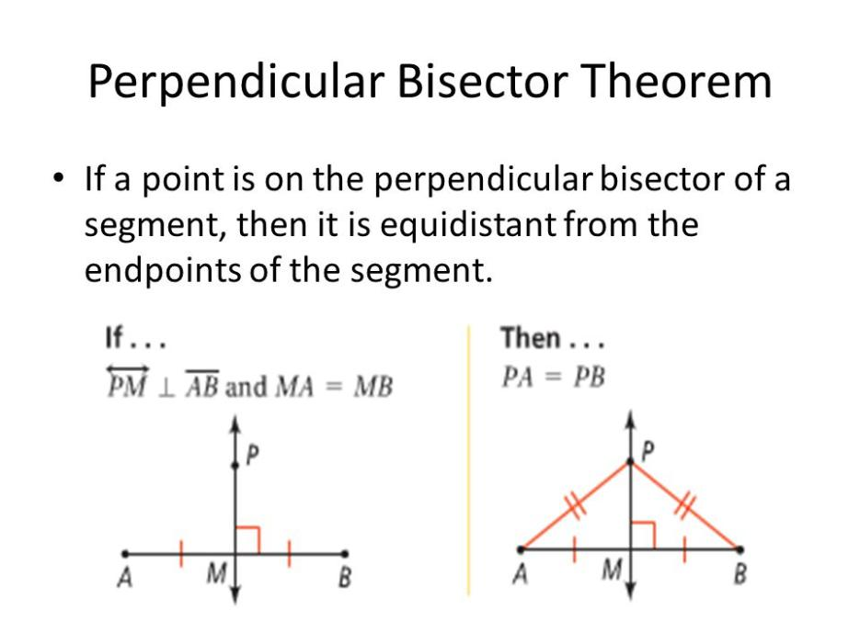
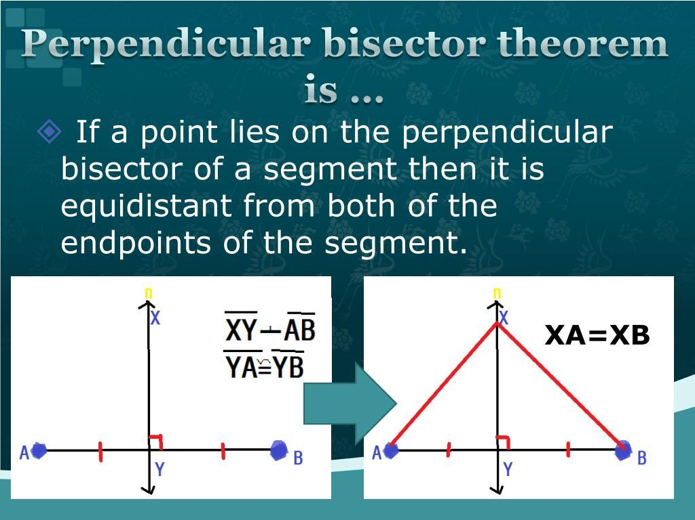
Example
If $P$lies on the perpendicular bisector of $\overset{‾}{AB}$, and:
$$PA=12$$
then:
$$\boxed{PB=12}$$

Converse of the Perpendicular Bisector Theorem
# Source: AI Source: Provided by: [Data Path: Persons Table -> ID Column: 1, Name_En Column: Motasem Essam] -> From: [ChatGPT] on [7/25/2026]
The converse states:
Any point that is equidistant from the endpoints of a segment lies on the perpendicular bisector of that segment.
If:
$$PA=PB$$
then $P$lies on the perpendicular bisector of $\overset{‾}{AB}$.
Therefore:
$$\boxed{PA=PB ⟺ P\text{ lies on the perpendicular bisector of }\overset{‾}{AB}}$$

Example 1: Finding the Midpoint
# Source: AI Source: Provided by: [Data Path: Persons Table -> ID Column: 1, Name_En Column: Motasem Essam] -> From: [ChatGPT] on [7/25/2026]
Suppose:
$$AB=18$$
and $l$ is the perpendicular bisector of $\overset{‾}{AB}$.
Since it bisects the segment:
$$AM=MB$$
Therefore:
$$AM=MB=\frac{18}{2} \\ \boxed{AM=MB=9}$$

Example 2: Finding an Unknown Length
# Source: AI Source: Provided by: [Data Path: Persons Table -> ID Column: 1, Name_En Column: Motasem Essam] -> From: [ChatGPT] on [7/25/2026]
Suppose $P$lies on the perpendicular bisector of $\overset{‾}{AB}$, and:
$$PA=3x+2 \\ PB=5x-8$$
Because $P$lies on the perpendicular bisector:
$$PA=PB$$
Therefore:
$$3x+2=5x-8 \\ 10=2x \\ x=5$$
Then:
$$PA=3\left(5\right)+2=17$$
and:
$$PB=5\left(5\right)-8=17$$
Thus:
$$\boxed{PA=PB=17}$$

Perpendicular Bisector in a Triangle
# Source: AI Source: Provided by: [Data Path: Persons Table -> ID Column: 1, Name_En Column: Motasem Essam] -> From: [ChatGPT] on [7/25/2026]
Every triangle has three perpendicular bisectors, one for each side.
These three perpendicular bisectors intersect at a single point called the circumcenter.
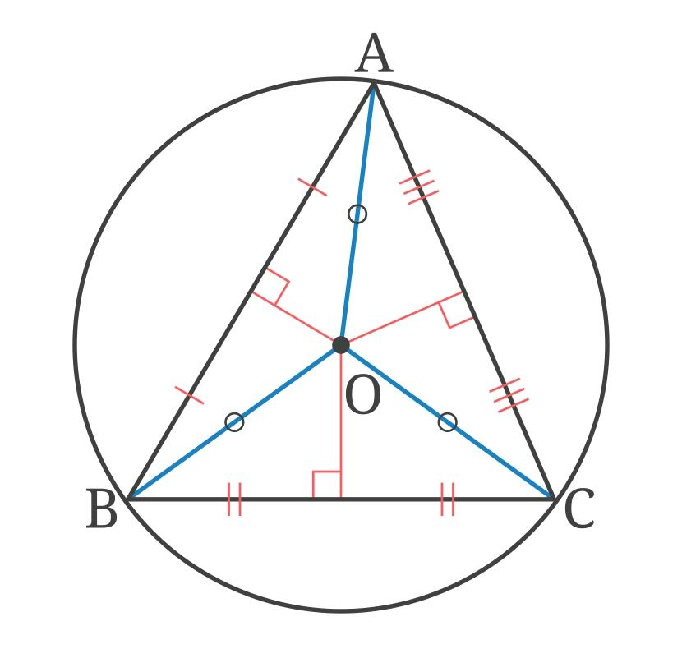
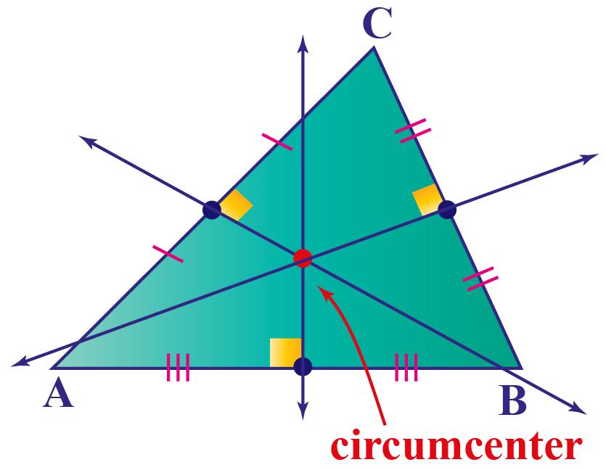
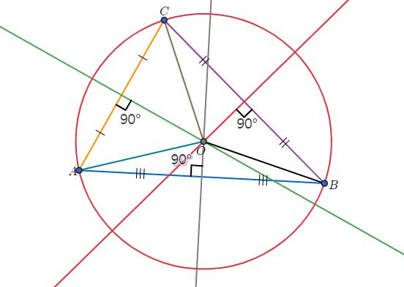
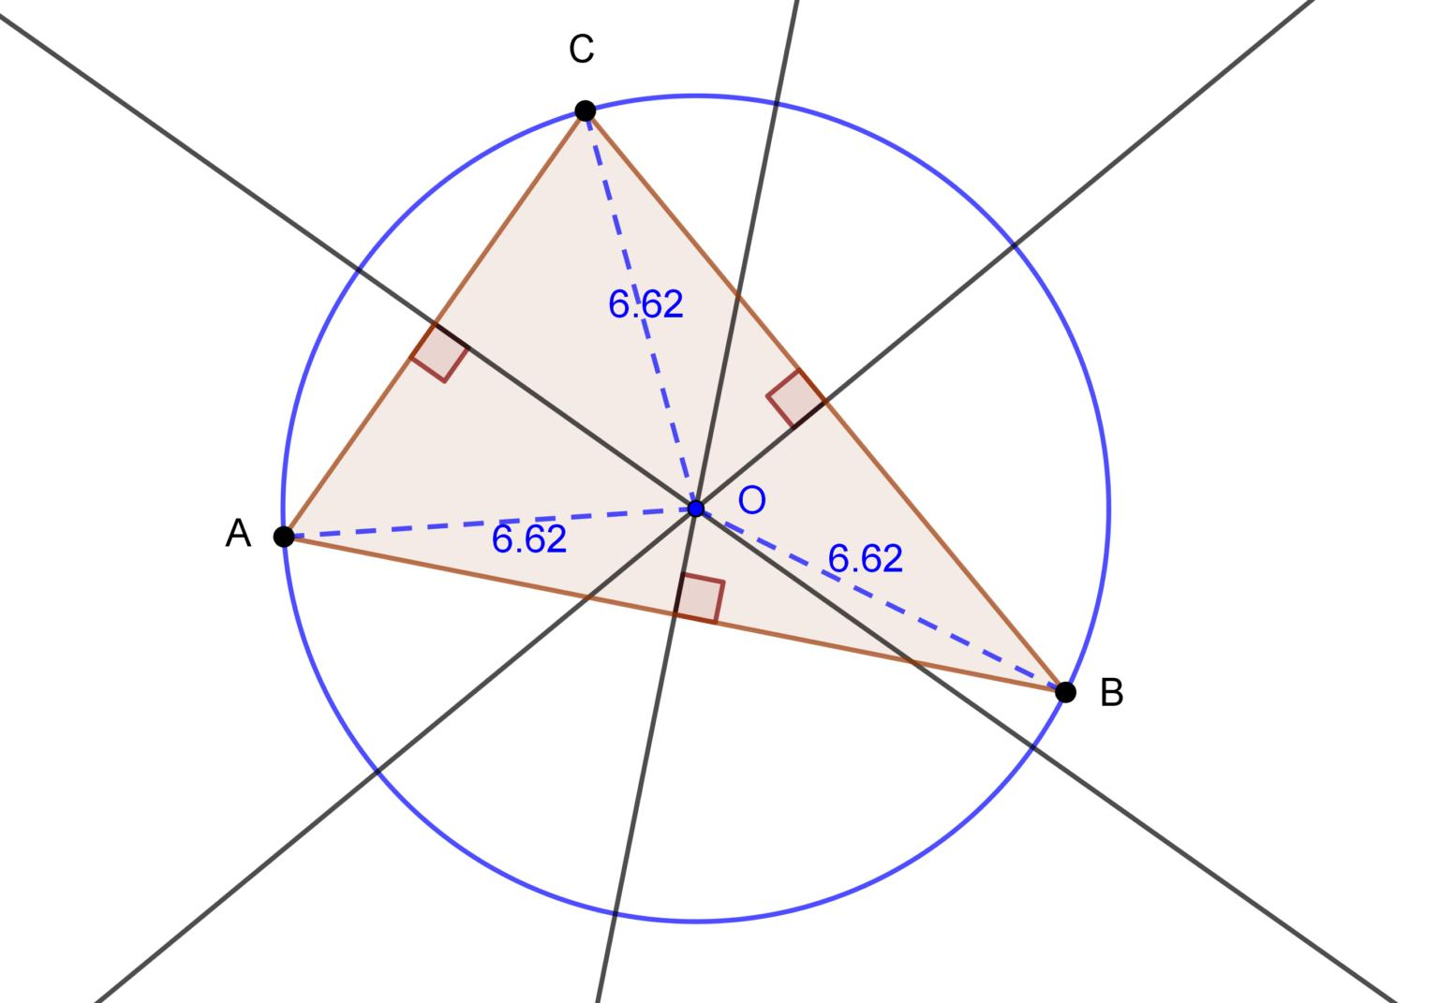
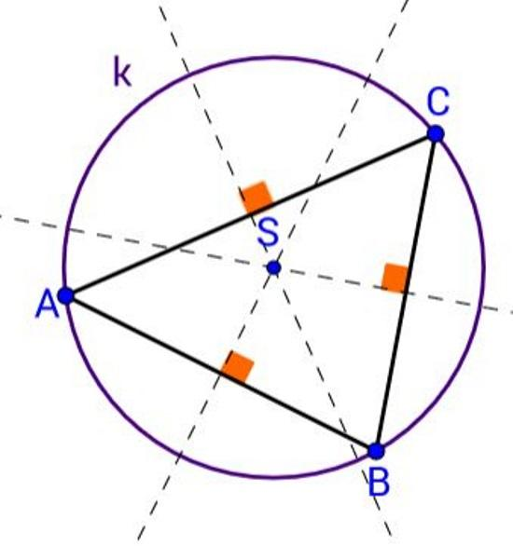
If $O$is the circumcenter of $△ABC$, then:
$$\boxed{OA=OB=OC}$$
Therefore, $O$ is equidistant from all three vertices.

Circumcircle Connection
# Source: AI Source: Provided by: [Data Path: Persons Table -> ID Column: 1, Name_En Column: Motasem Essam] -> From: [ChatGPT] on [7/25/2026]
Because:
$$OA=OB=OC$$
a circle centered at $O$ can pass through all three vertices.
This circle is called the circumcircle.
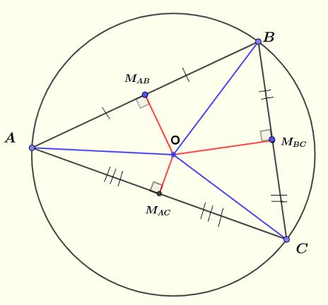
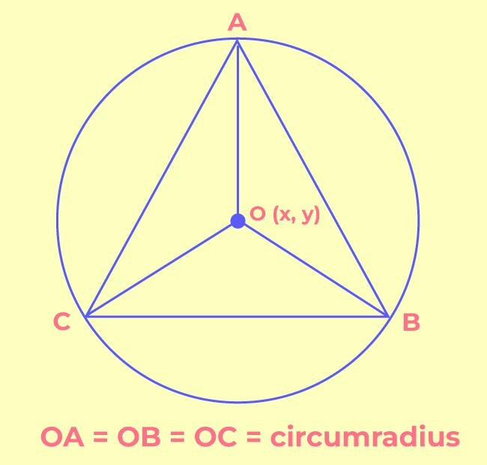
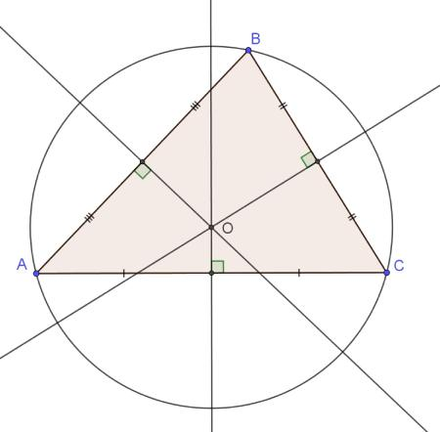
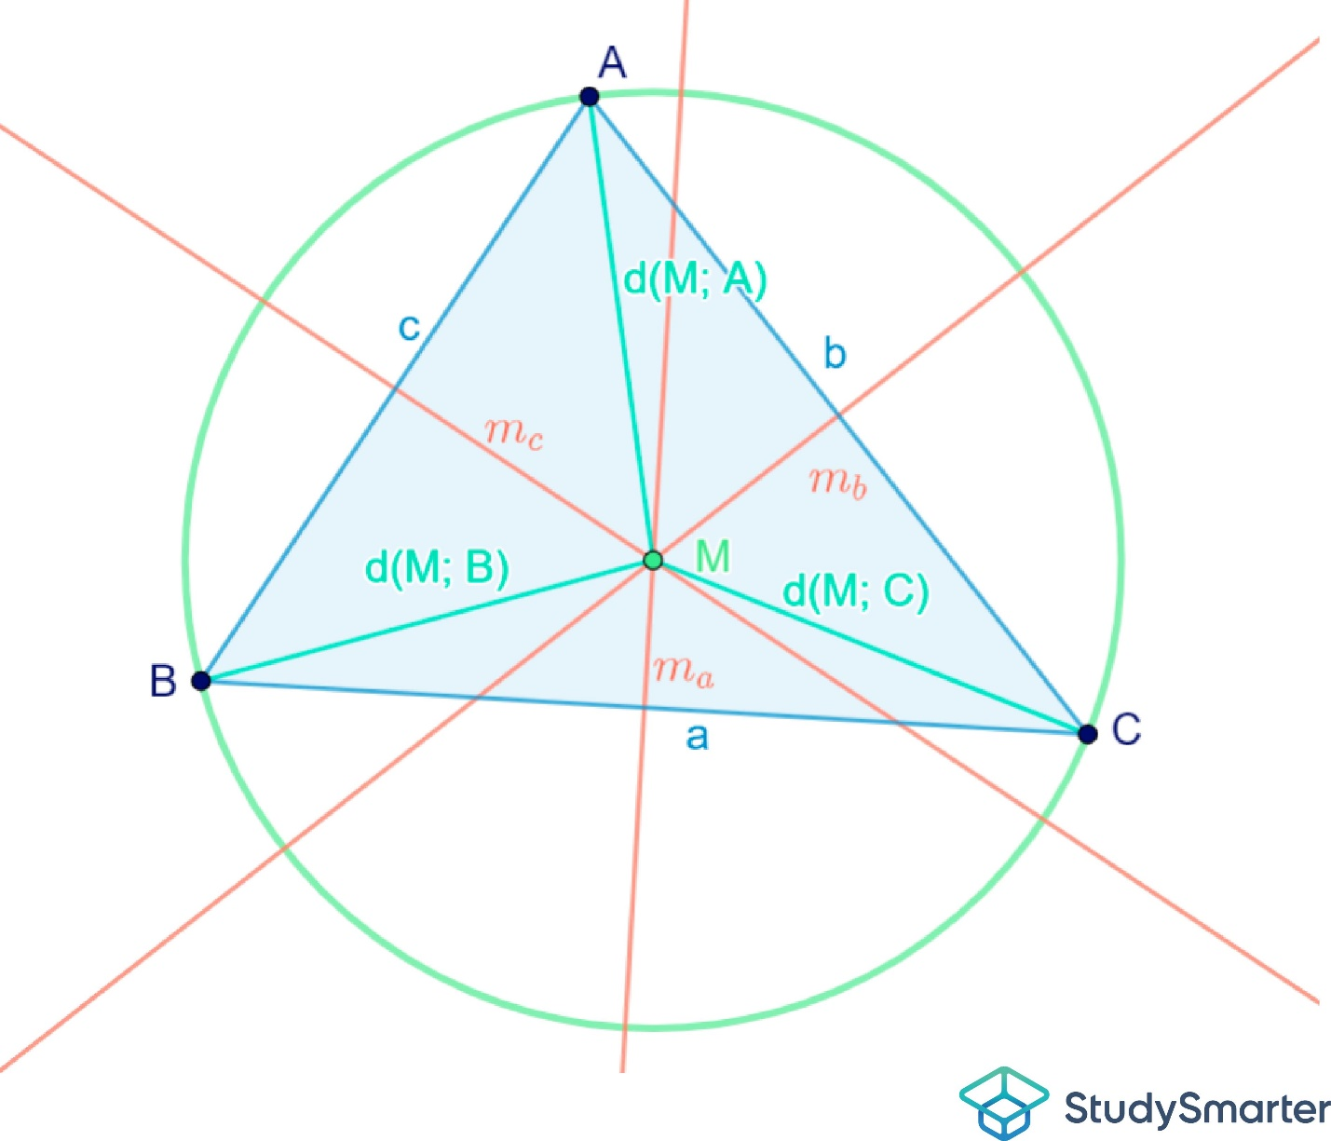
The radius is:
$$\boxed{R=OA=OB=OC}$$

Constructing a Perpendicular Bisector
# Source: AI Source: Provided by: [Data Path: Persons Table -> ID Column: 1, Name_En Column: Motasem Essam] -> From: [ChatGPT] on [7/25/2026]
A perpendicular bisector can be constructed using a compass and straightedge.
Steps
- Draw segment $\overset{‾}{AB}$.
- Open the compass to a width greater than half of $AB$.
- Place the compass at $A$and draw arcs above and below the segment.
- Without changing the compass width, place it at $B$.
- Draw arcs intersecting the first pair of arcs.
- Draw a line through the two arc-intersection points.
The resulting line is the perpendicular bisector of $\overset{‾}{AB}$.
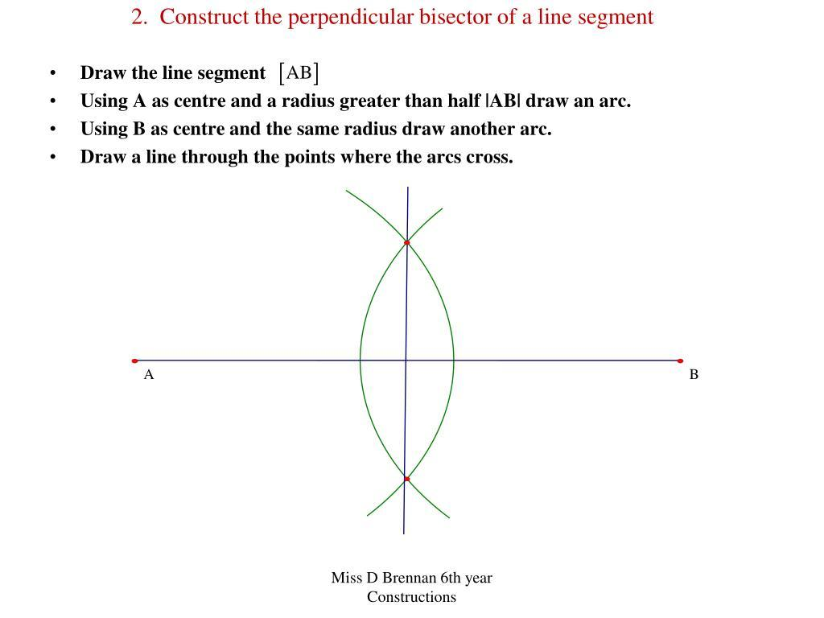
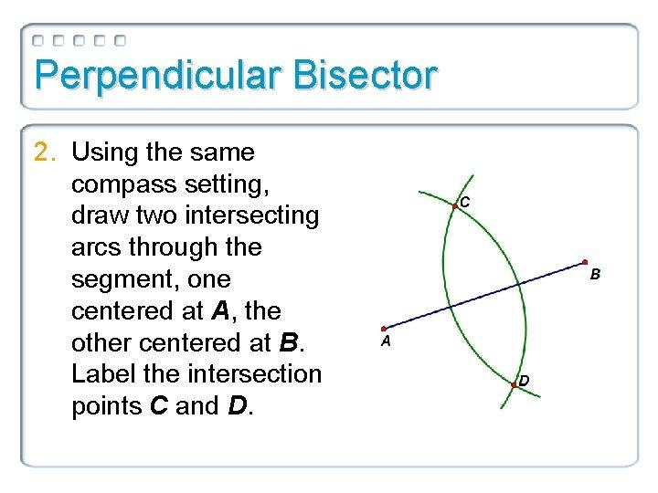
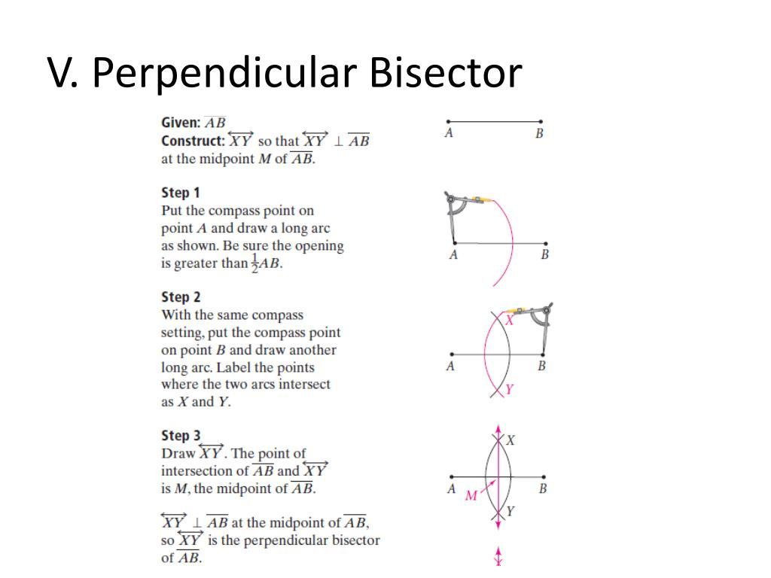

Why the Construction Works
# Source: AI Source: Provided by: [Data Path: Persons Table -> ID Column: 1, Name_En Column: Motasem Essam] -> From: [ChatGPT] on [7/25/2026]
Let the upper intersection point be $P$.
Because the compass was used with the same radius from $A$and $B$:
$$PA=PB$$
Similarly, for the lower intersection point $Q$:
$$QA=QB$$
Therefore, both $P$and $Q$are equidistant from $A$and $B$.
By the converse of the Perpendicular Bisector Theorem, both points lie on the perpendicular bisector of $\overset{‾}{AB}$.
Thus, the line $PQ$is the perpendicular bisector.

Coordinate Geometry
# Source: AI Source: Provided by: [Data Path: Persons Table -> ID Column: 1, Name_En Column: Motasem Essam] -> From: [ChatGPT] on [7/25/2026]
For:
$$A\left(x_{1} , y_{1}\right)$$
and:
$$B\left(x_{2} , y_{2}\right)$$
the midpoint is:
$$\boxed{M\left(\frac{x_{1}+x_{2}}{2} , \frac{y_{1}+y_{2}}{2}\right)}$$
The slope of $\overset{‾}{AB}$, when $x_{1}≠x_{2}$, is:
$$m_{AB}=\frac{y_{2}-y_{1}}{x_{2}-x_{1}}$$
The perpendicular bisector has slope:
$$\boxed{m_{l}=-\frac{1}{m_{AB}}}$$
when the original segment has a nonzero finite slope.

Example 3: Coordinate Perpendicular Bisector
# Source: AI Source: Provided by: [Data Path: Persons Table -> ID Column: 1, Name_En Column: Motasem Essam] -> From: [ChatGPT] on [7/25/2026]
Given:
$$A\left(2 , 3\right)$$
and:
$$B\left(8 , 7\right)$$
Step 1: Find the midpoint
$$M=\left(\frac{2+8}{2} , \frac{3+7}{2}\right) \\ M=\left(5 , 5\right)$$
Step 2: Find the slope of $AB$
$$m_{AB}=\frac{7-3}{8-2}=\frac{4}{6}=\frac{2}{3}$$
Step 3: Find the perpendicular slope
$$m_{l}=-\frac{3}{2}$$
Step 4: Equation of the perpendicular bisector
Using point-slope form:
$$y-5=-\frac{3}{2}\left(x-5\right)$$
Therefore:
$$\boxed{y-5=-\frac{3}{2}\left(x-5\right)}$$

Special Cases in Coordinates

Horizontal Segment
# Source: AI Source: Provided by: [Data Path: Persons Table -> ID Column: 1, Name_En Column: Motasem Essam] -> From: [ChatGPT] on [7/25/2026]
If:
$$A\left(2 , 4\right), B\left(8 , 4\right)$$
then the perpendicular bisector is vertical.
The midpoint is:
$$M\left(5 , 4\right)$$
Therefore:
$$\boxed{x=5}$$

Vertical Segment
# Source: AI Source: Provided by: [Data Path: Persons Table -> ID Column: 1, Name_En Column: Motasem Essam] -> From: [ChatGPT] on [7/25/2026]
If:
$$A\left(5 , 2\right), B\left(5 , 8\right)$$
then the perpendicular bisector is horizontal.
The midpoint is:
$$M\left(5 , 5\right)$$
Therefore:
$$\boxed{y=5}$$

Perpendicular Bisector vs. Segment Bisector
# Source: AI Source: Provided by: [Data Path: Persons Table -> ID Column: 1, Name_En Column: Motasem Essam] -> From: [ChatGPT] on [7/25/2026]
A perpendicular bisector is a special type of segment bisector.
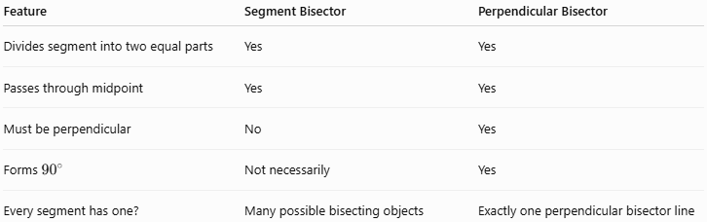
Feature | Segment Bisector | Perpendicular Bisector
Divides segment into two equal parts | Yes | Yes
Passes through midpoint | Yes | Yes
Must be perpendicular | No | Yes
Forms ${90}^{∘}$ | Not necessarily | Yes
Every segment has one? | Many possible bisecting objects | Exactly one perpendicular bisector line

Perpendicular Bisector vs. Angle Bisector
# Source: AI Source: Provided by: [Data Path: Persons Table -> ID Column: 1, Name_En Column: Motasem Essam] -> From: [ChatGPT] on [7/25/2026]
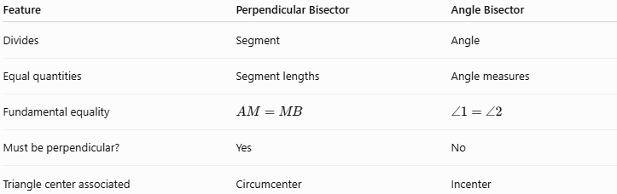
Feature | Perpendicular Bisector | Angle Bisector
Divides | Segment | Angle
Equal quantities | Segment lengths | Angle measures
Fundamental equality | $$AM=MB$$ | $$∠1=∠2$$
Must be perpendicular? | Yes | No
Triangle center associated | Circumcenter | Incenter

Important Distinction
# Source: AI Source: Provided by: [Data Path: Persons Table -> ID Column: 1, Name_En Column: Motasem Essam] -> From: [ChatGPT] on [7/25/2026]
A perpendicular bisector does not necessarily pass through the endpoints of the segment.
For:
$$\overset{‾}{AB}$$
the perpendicular bisector crosses the segment at its midpoint $M$:
$$A∙⟶M⟶∙B$$
while the perpendicular bisector continues infinitely in both directions.

Real-World Applications
# Source: AI Source: Provided by: [Data Path: Persons Table -> ID Column: 1, Name_En Column: Motasem Essam] -> From: [ChatGPT] on [7/25/2026]
Perpendicular bisectors are used in:
- Architecture
- Construction
- Engineering
- Surveying
- Computer graphics
- Geographic mapping
- Navigation
- Land division
- Symmetrical design
Example: Equidistant Location
Suppose two locations are represented by points $A$and $B$.
Every point on their perpendicular bisector is the same distance from $A$ and $B$.
This makes perpendicular bisectors useful when determining locations that must be equally distant from two reference points.

Advantages
# Source: AI Source: Provided by: [Data Path: Persons Table -> ID Column: 1, Name_En Column: Motasem Essam] -> From: [ChatGPT] on [7/25/2026]
- Precisely identifies the midpoint of a segment.
- Provides a geometric method for finding equidistant points.
- Helps construct the circumcenter and circumcircle.
- Useful for geometric constructions.
- Provides a strong connection between distance and perpendicularity.

Limitations
# Source: AI Source: Provided by: [Data Path: Persons Table -> ID Column: 1, Name_En Column: Motasem Essam] -> From: [ChatGPT] on [7/25/2026]
- A perpendicular bisector is specific to a line segment.
- It should not be confused with an angle bisector.
- A general segment bisector does not have to be perpendicular.
- Coordinate methods involving slopes require special handling for vertical or horizontal segments.

Relationship with Related Concepts
# Source: AI Source: Provided by: [Data Path: Persons Table -> ID Column: 1, Name_En Column: Motasem Essam] -> From: [ChatGPT] on [7/25/2026]
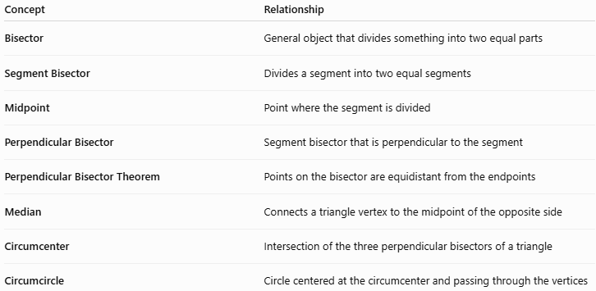
Concept | Relationship
Bisector | General object that divides something into two equal parts
Segment Bisector | Divides a segment into two equal segments
Midpoint | Point where the segment is divided
Perpendicular Bisector | Segment bisector that is perpendicular to the segment
Perpendicular Bisector Theorem | Points on the bisector are equidistant from the endpoints
Median | Connects a triangle vertex to the midpoint of the opposite side
Circumcenter | Intersection of the three perpendicular bisectors of a triangle
Circumcircle | Circle centered at the circumcenter and passing through the vertices

Key Points
# Source: AI Source: Provided by: [Data Path: Persons Table -> ID Column: 1, Name_En Column: Motasem Essam] -> From: [ChatGPT] on [7/25/2026]
- A perpendicular bisector divides a segment into two equal parts at ${90}^{∘}$.
- If $M$is the intersection with $\overset{‾}{AB}$:
$$\boxed{AM=MB}$$
- The perpendicular relationship is:
$$\boxed{l⊥\overset{‾}{AB}}$$
- Any point on the perpendicular bisector is equidistant from the segment's endpoints:
$$\boxed{PA=PB}$$
- The converse is also true.
- The three perpendicular bisectors of a triangle meet at the circumcenter.
- The circumcenter is equidistant from all three vertices:
$$\boxed{OA=OB=OC}$$

Conclusion
# Source: AI Source: Provided by: [Data Path: Persons Table -> ID Column: 1, Name_En Column: Motasem Essam] -> From: [ChatGPT] on [7/25/2026]
A perpendicular bisector is a special type of segment bisector that divides a segment into two equal parts while crossing it at a right angle. Its most important property is the relationship between perpendicularity and equal distance, making it fundamental to the Perpendicular Bisector Theorem, circumcenter, circumcircle, and geometric constructions.

